3 Part Haematology Analyzer BC 20s

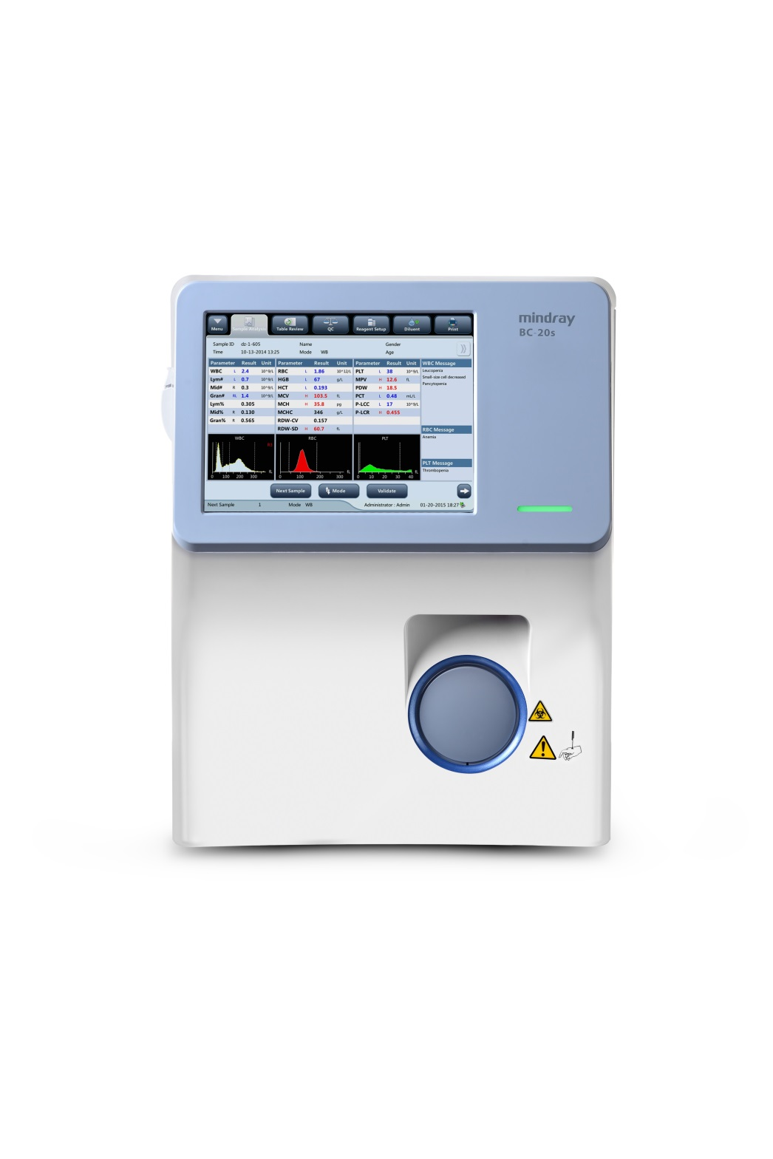

Miindray BC 20s – 3 part Hematology Analyzer

Features:

* 3 Part Differential Hematology Analyzer
* Double Chamber
* Storage of 2,00,000 Results with data & graphics
* Use of only 2 Reagents for routine counting
* CBC+Diff, 19 parameters & 3 Histograms
* Throughput of 40 Samples.Hour

3 Part Haematology Analyzer AVENZA AH30





5 Part Haematology Analyzer BC 5130

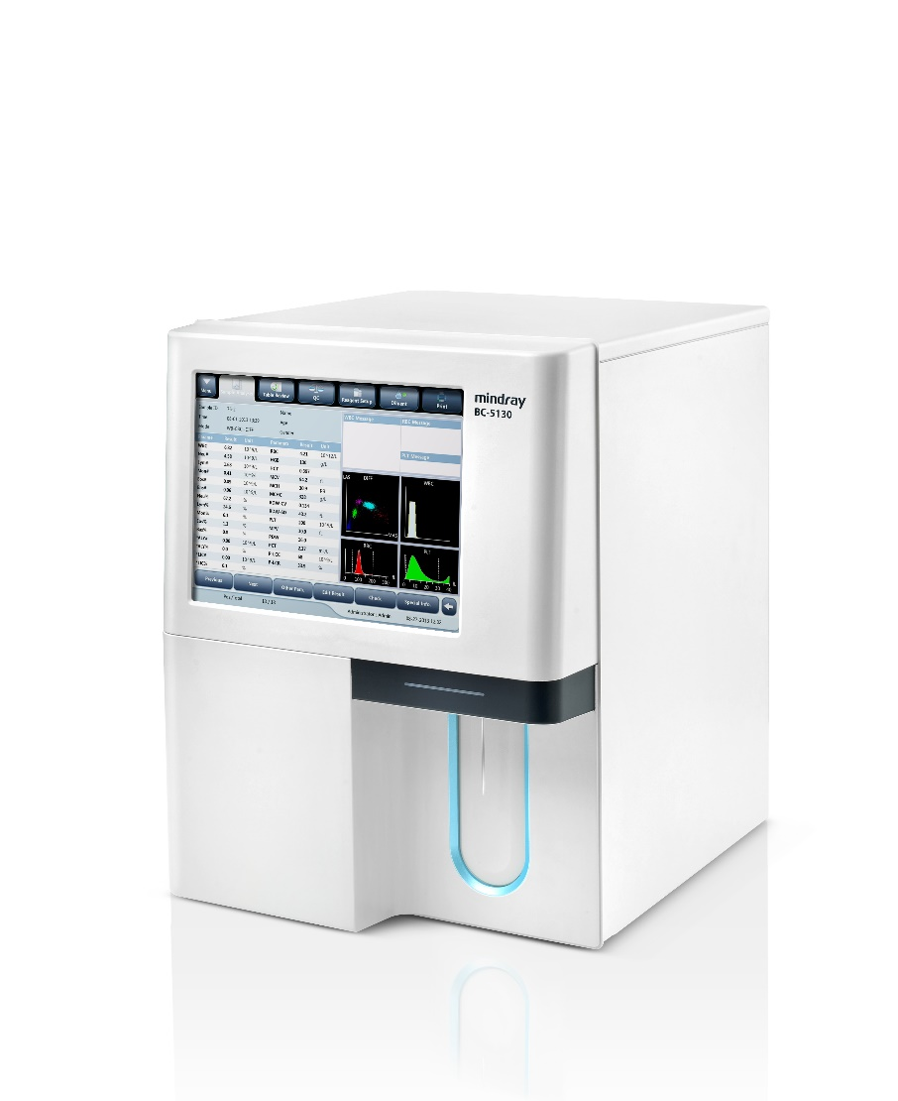

Mindray BC 5130 – 5 part Haematology Analyzer.

* Lightest and most Compact 5 - Part haematology Analyzer.
* Tri-Angle Laser Scatter+ Chemical Dye+ Flow cytometry technology for better performance.
* 25 Reportable parameters with 3 Histograms and 4 scattergrams for WBC Differential.
* Running Capillary blood through the sample probe directly is convenient in paediatric samples.
* Data Storage up to 150,000 results.

High End Haematology Analyzer BC 700 series

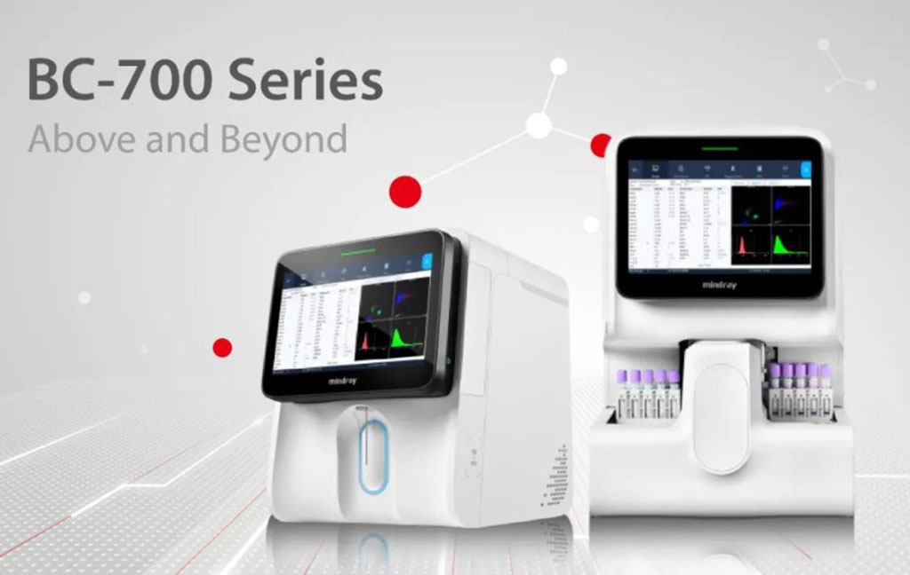

* SF Cube fluorescent technology allows reliable counting and differentiation of abnormal samples
* More reliable measurements for low- value samples.
* Optical PLT-H in every CD test and Schematic diagram of PLT-H.
* CD + ESR in one test provide reliable ESR results with greater ease.
* 33 reportable parameters. Whole blood and Body fluid measurement possible.
* An all-in-one solution that goes above and beyond your expectations

High Throughput 6 Part Haematology Analyzer BC 6000 series.

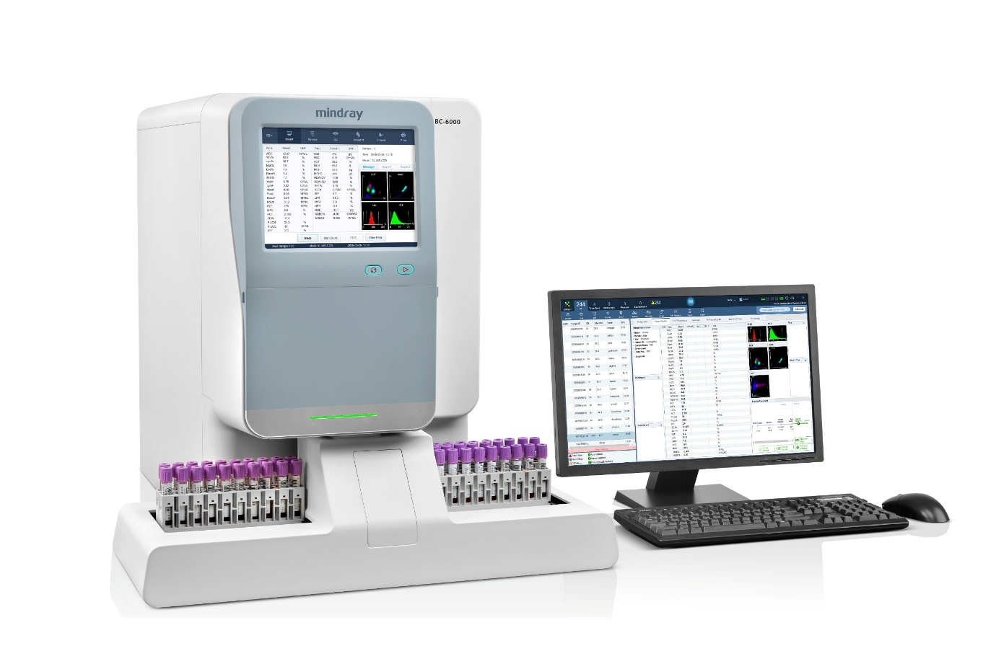

BC 6000 Series : BC 6000, BC 6200, BC 6800 Plus.

* The SF Cube technology can help doctors to better differentiate the clusters of cells, which is the key to revealing more abnormal cells.
* 29 reportable parameters 2 Histograms for RBC and PLT with 2 Histograms of RBC and PLT, 2 Three-dimension scatter grams: DIFF, WNB,2 Two-dimension scatter grams: DIFF, WNB.
* NRBC Results in each CBC. Reticulocytes profile in BC 6200.
* Throughput of 110 samples per hour.
* Up to 10,0000 results including numeric and graphical information.

Semi Auto Biochemistry Analyzer BA 88A



Mindray BA 88A Semi Auto Analyzer.

* Endpoint, Fixed-time, Kinetics and Absorbance
* Wavelengths range 340 to 670nm
* 7.0” TFT touch screen & popup keypad
* Up to 200tests can be programmed
* Testing mode: flowcell or cuvette
* User friendly interface
* Power-failure protection
* Universal power supply

Automated Bio-chemistry Analyzer BS 240



**Mindray BS 240 Automated Biochemistry Analyzer.**

* **Fully automated, compact & cost effective Discrete and random access Analyzer**
* **Throughput upto 200 tests/hour.**
* **Flexible loading upto 40 samples and 80 reagent positions**
* **Refrigerated compartment for both samples and reagents**
* **Minimal reagent volume 100**
* **whole blood testing function for HbA1c**
* **Auto-washing system ensures low carryover and**
* **consumes less water**
* **In-buit barcode reader**

**Fully Automated Bio -chemistry Analyzer BS 430**

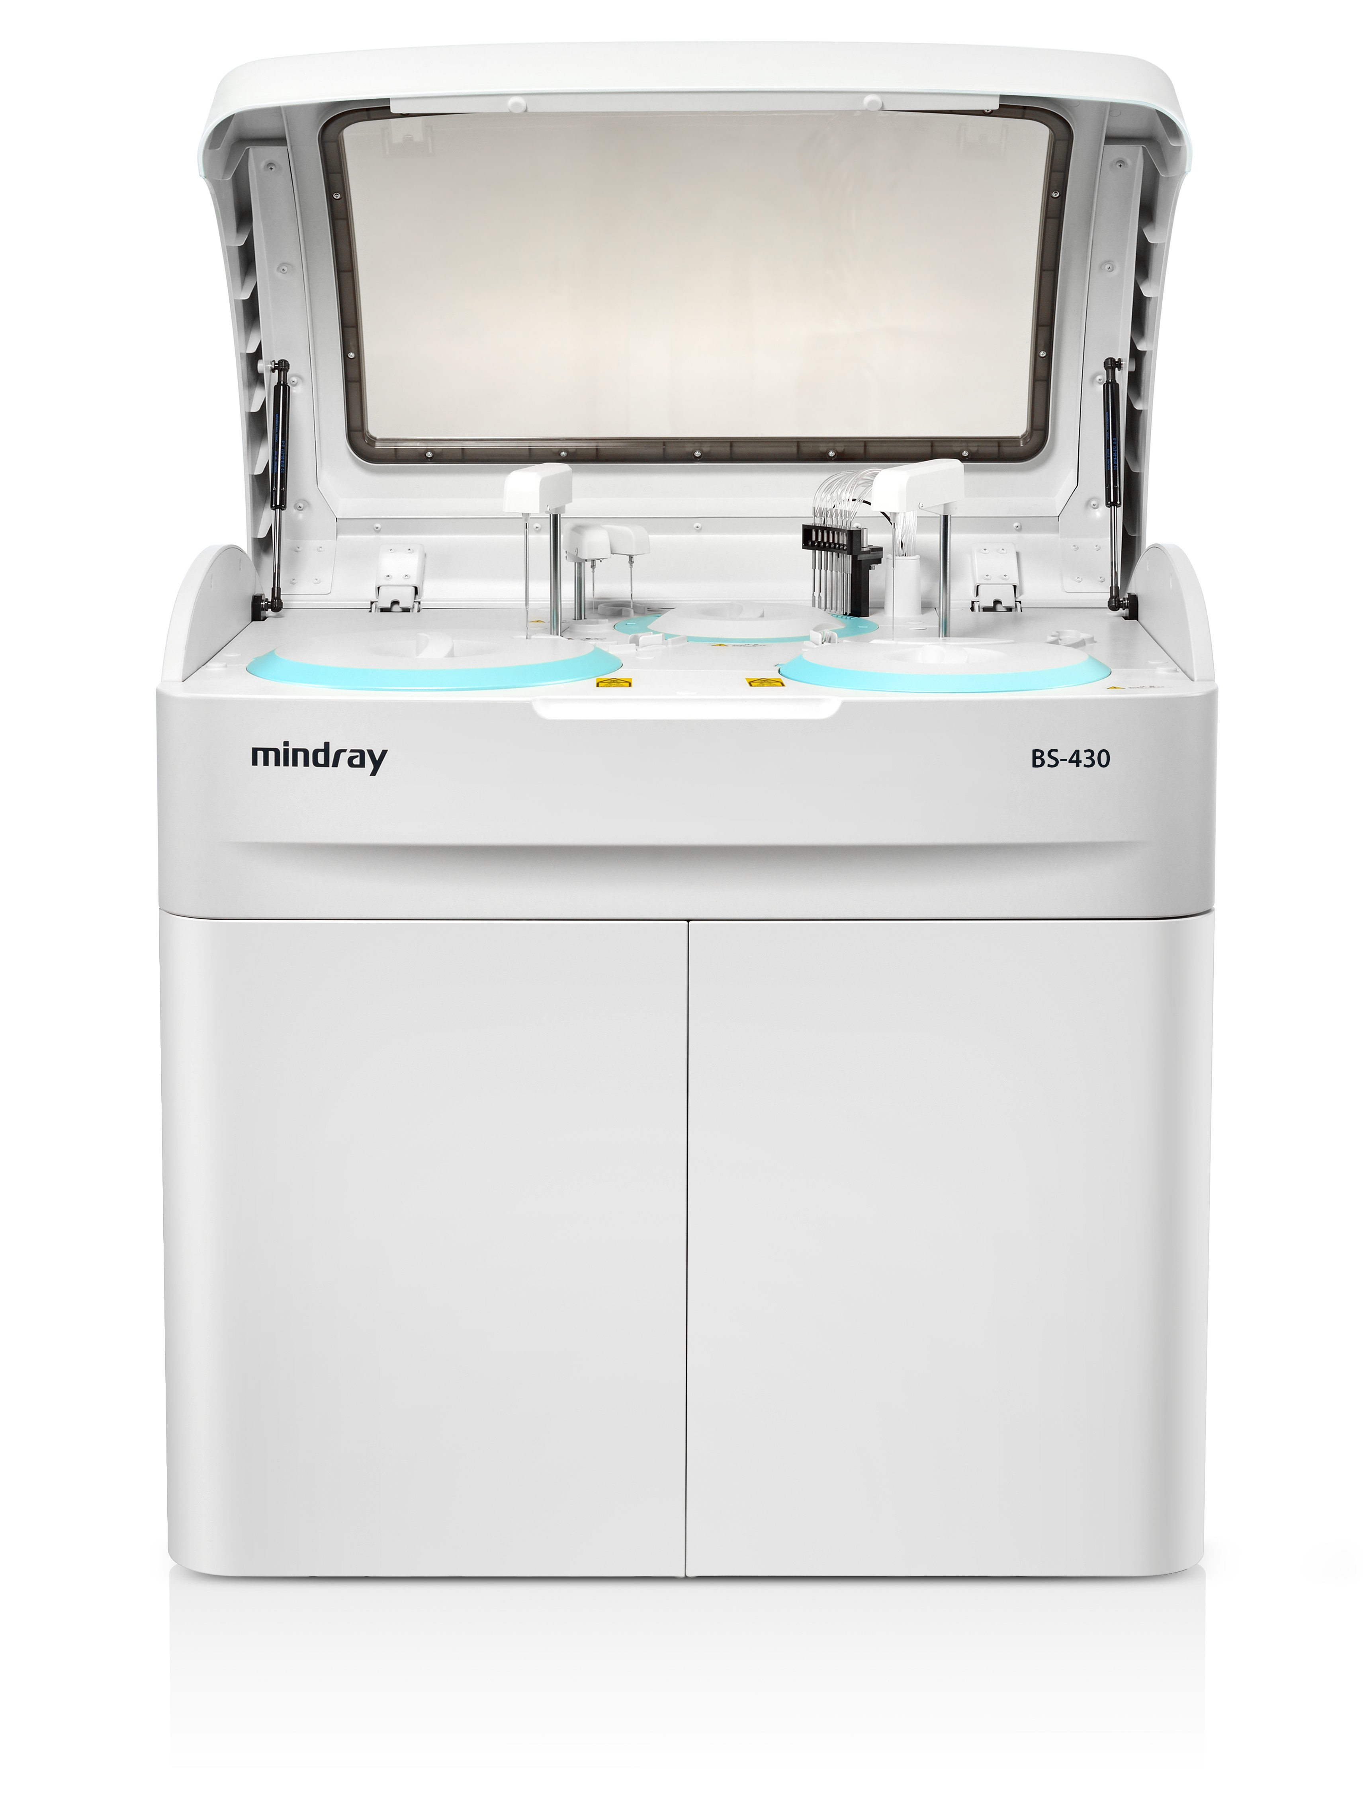

**Mindray BS 430 Automated Biochemistry Analyzer**

* **Large loading capacity: 92 reagent positions, 102 sample positions**
* **HbA1c smart sampling: supports HbA1c onboard hemolysis**
* **Advanced software platform: auto QC, auto reflex, substrate depletion & enzyme linearity extension, etc.**
* **Quick start-up time: 5 minutes system initialization, 1 minute system wake-up**
* **Low reagent consumption: minimal 100μl reaction volume**
* **Sample throughput: Constant 420 tests / h, up to 626 tests / h with ISE**

**Fully Automated Bio-Chemistry Analyzer BS 600M**

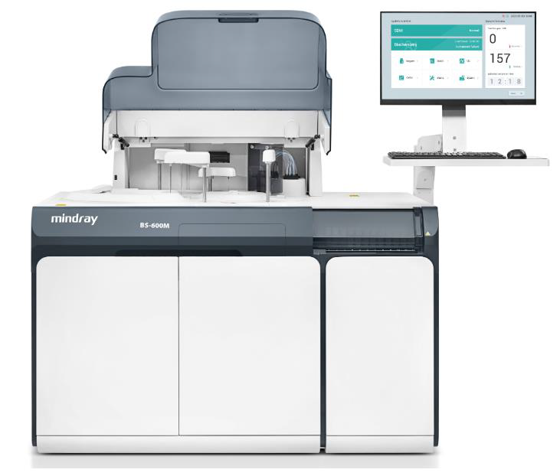

**Mindray BS 600M Automated Chemistry Analyzer with ISE.**

* **Flexible Sample Management**
* **Integrated ISE Module**
* **HbA1c Tests with Whole Blood**
* **Reliable Testing System**
* **High cost efficiency and easy to use**
* **Sample continuous loading by racks and STAT priority**
* **Throughput – Routine Chemistry 600 tests/hour, up to 770 tests/hour with ISE.**

**Semi Auto Analyzer**

**ARIS - 100**



**Multiple User Logins & Activity Tracking**

**Built-in Digital Timers for Incubation**

**Mandatory Wash Between Tests**

**Lamp Life Monitoring & Replacement Alert**

**Auto-Sleep Function User-Enabled Lamp Replacement**

**Hyper-Active Sample Warning Smart Dilution Recommendation**

**New Factor Confirmation for Calibration**

**Immunoassay/Hormone Analysers:**

**Maglumi 800/ 2000/ X3/X6**

**Automated Immunoassay Analyzer Maglumi X3**



**One of the highest space efficiency CLIA analyzers combines one of the broadest automated CLIA test menus.**

**The throughput is up to 200 tests/hour (Throughput per unit area is 294 T/h/m²). No worry about the lack of laboratory space.**

**MAGLUMI® reagent kits (166 parameters) and consumables are compatible with MAGLUMI® X3.**

**The comprehensive advanced design of MAGLUMI® X3 ensures excellent performance.**

**Single reaction cup can avoid light pollution and increase cuvette utilization, its integrated packaging can avoid the stuck of the cuvette and destroying the cuvette wall.**

**No-pause loading/unloading of reagents/samples without waiting or interrupting tests.**

**Pipetting detection technologies include liquid level, clot, and crash detection can ensure accurate and normal pipetting.**

**The latest intelligent washing technology and bidirectional temperature control measurement guarantee accurate and reliable results.**

**Intelligent UI interface, user-friendly, easy, and convenient operation.**

**Intuitive indicator light make users no need to check reagents and consumables frequently.**

**Automated Immunoassay Analyzer Maglumi X6**



**● Throughput: 450 T/H**

**● On board capability: 112/412 samples**

**● Throughput per unit area: up to 320 T/H/m2**

**● Reagent position: 30**

**● Walk-away tests: up to 2000 tests**

**● Cuvettes loading in one time: up to 2002**

**Based on X-Tech, gives you more possibility**